|  |
| --- |
| Curriculam vitae of  MD. FOYSAL ALAM  Sayed Nagar, Vatara  +8801834231764  Foysalalam800@gmail.com.  <https://www.facebook.com/profile.php?id=100005093624586>  [https://www.linkedin.com/in/md- foysal-mahmud-shah-7157a4134/](https://www.linkedin.com/in/md-%20%20foysal-mahmud-shah-7157a4134/) |

|  |  |
| --- | --- |
|  | Objective |

I am a self starter with strong interpersonal skills. I work efficiently both as an individual contributor as well as along with a team. I seek new challenges and try to think outside of the box while looking for creative solutions to a given problem. I believe in character, values, vision and action. I am a quick learner and believe in learning from my mistakes for I strongly feel that this virtue will take me ahead in my life and career.

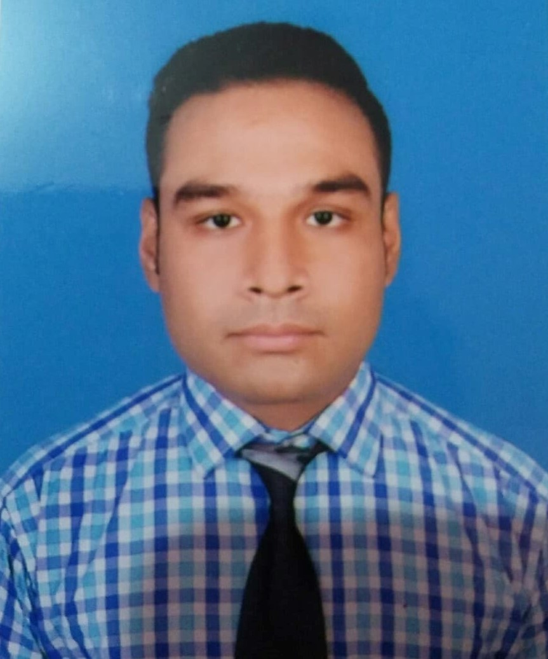

|  |  |
| --- | --- |
|  | Education |

## BBA in Marketing | United International University.

### may 28, 2015 – Present

Cgpa: 2.76

## HSC | New Government Degree College, Rajshahi .

### July 1,2011 – march 31, 2013

### Department- business studies

Gpa 5.00

## SSC| K.D Government High School, Naogaon .

### january 1, 2003– march 28.2011

### department- business studies

Gpa 5.00

|  |  |
| --- | --- |
|  | Experience |

## Campus Ambassador | bKash Limited

### july 28,2019 – December 15 2019

[Arranging the event of App launching and encourage all the students for opening a bkash account , doing ekyc Plan In & out campus activities , Organization visit ,corporate activation , account opening and refer app link to friends by social media for downloading the app and opening a bKash account and using the app]

**Campus Ambassador | Careers Hub, Bangladesh**

july 24,2019 – october 17 2019

[Arranging a seminar in the campus and encourage all the students for doing the courses]

**Internship | BDhousing.com**

february 05,2020 – Present

[Plan and execute all digital marketing, including SEO ,marketing database, email and social media, Brainstorm new and creative growth strategies, Devising strategies to drive online traffic to the BDhousing website, Developing and managing digital marketing campaigns on social media, Evaluating Customer research, market conditions and competitor data and content writing]



**Memberships**

## Literary editor | UIU Prothom Alo Bohdhushova

### April 08,2016 – March 3, 2018

## Marketing Executive | UIU Skill Development Forum

### Auguest 24,2017 – february 10, 2018

## General Member| UIU Marketing Forum

### November 02,2018 – february 23, 2019

## Action Team Member| UIU HR Forum

### june 15,2019 – present

|  |  |
| --- | --- |
|  | Skills |

|  |  |  |  |  |  |  |  |  |  |  |  |  |  |  |  |  |  |  |  |  |  |  |  |  |  |  |  |  |  |  |  |  |
| --- | --- | --- | --- | --- | --- | --- | --- | --- | --- | --- | --- | --- | --- | --- | --- | --- | --- | --- | --- | --- | --- | --- | --- | --- | --- | --- | --- | --- | --- | --- | --- | --- |
| **PROFESSIONAL COMPETENCIES**   |  | | --- | | * Computer Competency | | * Client service | | * Creative Thinking | | * Forward Thinking | | * Conceptual Thinking | | * Conflict Resoulation | | * Decision Making | | * Excellent Communication | | * Flexibility | | * Writing skills |   **AREAS OF EXPERTISE**   |  |  |  | | --- | --- | --- | | * Fluent in English | * Communication skills | * Convenience power | | * Ms Word | * Researcher | * Analytical ability | | * Power point * Teamwork | * Leadership * MS Excel * SPSS | * Presentation skills * Digital Marketing Facts (Social Media Marketing, Google Adward, You Tube Marketing, Content Writing & SEO) | |  |  |  |   **PERSONAL COMPETENCIES**   |  | | --- | | * Teamwork | | * Responsibility | | * Commitment to career | | * Career motivation | | * Decision making * Communication | | * Leadership | | * Trustworthiness and Ethics | | * Problem Solving | | * Top Technical Skills | |  |

|  |  |
| --- | --- |
|  | Activities |

|  |
| --- |
| * Event Management of UIU Skill Development Forum and UIU Marketing Forum in 2017. |
| * Excel’s Training and Competition 2nd round in 2018 presented by UIU Finance Forum in 2018. |
| * Training on Presentation Masterclass by UIU Junior Economist Forum in 2018. |
| * Attended all Seminars and Workshop of Manusher Jonno Foundation of IDSS IDSS in 2018-19. |
| * Attended Career Booth camp in 2019 by UIU HR forum. |
| * Attended National Career Conferences in 2018 by UIU HR Forum. |
|  |
| * Organizer to represent UIU Marketing forum at UIU Club forum feast in 2018. |
| * Attended Career Talk 2019 by UIU Business Club. * Seminar on “Global Vendor Management and Communication” by KITC supported by UIU CCC in 2019. * Seminar on “ Edge of Entrepreneur” Presented by UIU Entrepreneur Development Forum in 2019. * Attended Career Session “Learn from the Leaders” by Banglalink supported by UIU Casper. * Attended Seminar of “Career Canvas” Presented by UIU HR Forum and UIU 100 Club along with Career Care and CCC in 2019. * Attended Seminar on “Women Marketers Day 2.0- Enlightened with Women Empowerment! Presented by UIU Marketing Forum in 2019. * Attended workshop on Public Speaking & Debate Presented by UIU Debate Club in 2019. * Attended Graphics Design Workshop with creative IT presented by UIU The 100 Club in 2019. * Attended Session about Business Analytics and Business Intelligence as a part of the unique initiative “Learn from the Leaders” by Casper UIU in 2019. * Attended Session on 'Strategic Communication & Corporate Etiquette' on “Career Lab #10” and presented by UIU HR Forum along with UIU CCC in 2019. * Attend Session on “Road show on Banglalink Ennovators 3.0” Presented by UIU Marketing Forum along with UIU CCC in 2019. * Attend a workshop on Graphics Design by “Career Hub Bangladesh” in 2019. * Attended a workshop on E- Commerce Presented by Daraz organized by UIU Entrepreneur Development Forum along with UIU CCC in 2019. * Attended a seminar on “Carrer Carnival 2019” presented by “Bproperty” and organized by UIU HR forum in 2019. * Attended a Career Session presented by “Carrerki” and organized by UIU Accounting Forum along with UIU CCC in 2019. * Attended a seminar on “IDLC Finance Olympiad” Presented by UIU Business Club in 2019. * A seminar on “Carrer Development through Business Automation Knowledge” organized by UIU MISF in 2019. * A seminar on “Language leage 2019” Presented by Detos organized by DEML – North South University in 2019. * A roadshow of the signature competition RB Global Challenge Bangladesh organized by UIU Marketing Forum in 2019. * Attended KITC Career Boot Camp Recruitment 2019 Replacement Talk Followed by Recruitment Exam Organized by UIU HR Forum. * Seminar on Entrepreneurship 360 ( Road to Hackathon) Organized by UIU EDF * Organizer of workshop on 'Career Lab # 11 presented by UIU CCC & UIU HR Forum. * Seminar on Employability Skills Program include Time management ,Cv writing and Interview tips and tricks organized by “Grow and Excel,” * Seminar Recruitment Session Conducted by Ethics Advanced Technology Limited (EATL) Organized by UIU HR Forum. |

**REFERENCES**



* **Muhammad Hasan Al Mamun**

Assistant Professor, School of Business & Economics, UIU.

Email: hamdhakabd@gmail.com

Phone no: 01712216556

* **Sarker Rafij Ahmed Ratan**

Assistant Professor, School of Business & Economics ,UIU.

Email: rafij@bus.uiu.ac.bd

Phone no: 0171650262684