Newaz Sharif Ahanaf  Address: 69/A, Helal-Market, Uttarkhan, Uttara, Dhaka 1230  Mobile: 01858230967  Email : newazsharifahanaf@gmail.com | 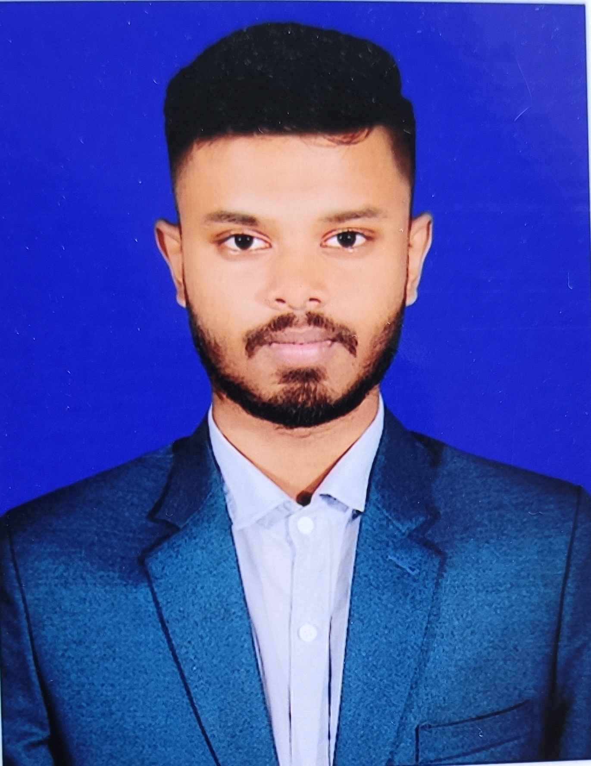

Career Objective
To achieve a successful career through devotion, commitment and hard work with an opportunity to work with people in an environment of excellence and passion where I can utilize my skills & experience.

Education

Honours
Institution : National University
Versity Name : Uttara Town University
Subject : Marketing
Grade : Honours 1st Year Running
HSC (Higher Secondary Certificate)
College Name : Uttara High School and College
Board : Dhaka
Grade(Point) : A (4.00) (Business Studies)
Passing year : 2019

SSC (Secondary School Certificate)
Institute Name : Shaheed Abu Taleb High School
Board : Dhaka
Grade(Point) : (A) 4.68 (Business Studies)
Passing year : 2017

Skills

Computer : Microsoft Office.Microsoft Excel, Microsoft Windows
Communication : Excellent interpersonal and communication skills.
Language : Mother tongue-Bengali, Have excellent communication Skill in written & oral over English and Bengali.
Others : Professional experience in Telecommunication related service operations;
- Being reliable, responsible, and dependable, and fulfilling obligations;
- Ability to work as part time, full time and a good listener & contributor;
- Ability to serve good explanation.
- Ability to cope with any change situation.
- Ability to work independently in a pressured environment.
- Ability to communicate with people of all ages, culture and geographic location.
Extra Curriculam Activities

- Experience as temporary office management executive in Uttara High School and College
- Bangladesh Society for Total Quality Management (BSTQM)_”Case Study” in Ahsanullah University of Science & Technology

Personal details

Father’s Name : Md. Shariful Islam Shipu
Mother’s Name : Luthfa Akter Tanzina
Date of Birth : 12th Octobor 2001
Marital Status : Unmarried
Nationality : Bangladeshi
Religion : Islam (Sunni)

Reference 01:
Name : Nazmul Islam
Designation : Software Engineer
Organization Name: DSi
Referee's Cell Number : +8801670216481
Email Address : nazmul.islam@dsinnovators.com
Office Address : House# 185, Road# 2, NEW DOHS, Mahakhali
Office Phone : +8801730034724
Relation with reference : Uncle (Family Member)

Reference 02:

Name: Khaled Ibnay Bashir
Designation :Senior Executive Officer, BACH, BEFTN & RTGS-In-Charge,
Organization Name :Modhumoti Bank Limited
Referee's Cell Number : +8801717645595
Email Address : khaled.bashir@modhumotibankltd.com
Office Address: DCCI Building (3rd Floor) 65-66 Motijheel C/A, Dhaka-1000, Bangladesh
Office Phone :+88029583809 Ext-4035
Relation with reference: Uncle (Family Member)

Newaz Sharif Ahanaf

