**Md. Asraful Islam**

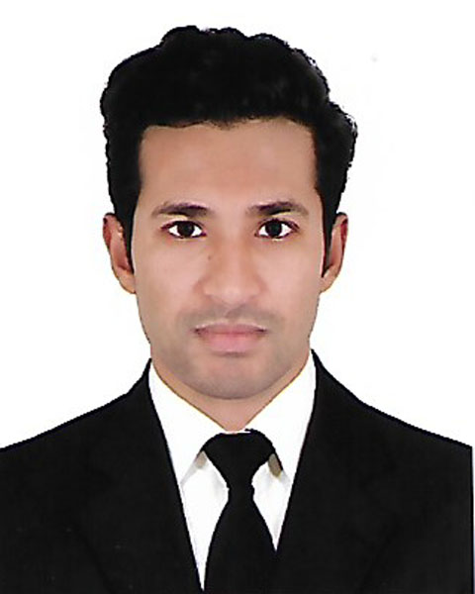

Ka-160/D, Mridha Bari, Kuril, Vatara, Dhaka-1229.

Contact: 01775961413, 01644403453

E-mail: asraful.[rubel2013@gmail.com](mailto:rubel2013@gmail.com)

|  |
| --- |
| Carrier Objective: |

I am seeking the opportunity in your company where I could shoulder the job responsibilities in the professional environment and attain self-growth as well.

|  |
| --- |
| Professional Experience |

1. Worked as a customer Manager at GrameenPhone.
2. Worked as Genex at Grameenphone Processing (Digital Marketing Communication)
3. Worked as Universal IT (International Call Center)
4. Worked as a student mentor of B.B.A. program.
5. Worked as a professional Web designer and developer and computer data entry operator at “INFO” Care Information and technology division.
6. Worked as a Program coordinator at Nourish Bangladesh. I managed 40 volunteer during the program of nourish Bangladesh at Bashundhara Convention Center.
7. I worked as a volunteer in International Youth Summit. I learned many things such as how to increase Leadership quality, Stress management, Team work, online market opportunity and Interpersonal communication.

|  |
| --- |
| Academic Qualification: |

* Masters of Business Administration (M.B.A)

University : National University

Institute : Mohammadpur Central University, Dhaka.

Subject : Management

* Bachelor of Business Administration (B.B.A)

University : National University

Institute : Mohammadpur Central University, Dhaka.

Subject : Management

Result : CGPA 2.87 out of 4.00

* Higher Secondary Certificate (H.S.C)

Institute : Ahmed Uddin Shah Shishu Nikatan School & College, Gaibandha.

Group : Business Studies

Board : Dinajpur

Result : GPA 4.20 out of 5.00

Passing year : 2012

* Secondary School Certificate (S.S.C)

Institute : Zigabari High School

Group : Humanities

Board : Dinajpur

Result : GPA 3.81 out of 5.00

Passing year : 2010

|  |
| --- |
| Academic Achievement: |

* Achieved “Dean Award” for outstanding academic performance
* Achieved Certificate for intra faculty business debate competition-2014
* Achieved Certificate from Bangladesh knowledge Management Initiative (BKMI).

|  |
| --- |
| Extra Curricular Activities: |

* Organize round table discussion with top leading corporate of Bangladesh
* Join Post Budget Reflection seminar (2015-2016) Chief Guest Dr. Salehuddin Ahmed
* Organize cultural program in Pohela Boishakh.
* Work as a volunteer at Mohammadpur Central University Blood Club.

|  |
| --- |
| Training Summary: |

* Training on how to improve your academic and career skill. Trainer “Nicky Wells” WSDA New Zealand.
* BRAC-Aarong’s training on Health Security Scheme for Rural Artisans. I had been attended two full days classroom session and performed six days of intensive field work at Ayesha Abed Foundation’s Jessore and Jhenaidah main center and sub-centers.
* Academy of learning limited Agents training program.

|  |
| --- |
| Language Proficiency: |

Fluency in reading, writing, listening, speaking English and Bengali.

|  |
| --- |
| Computer Proficiency: |

* Basic Computer knowledge in both Software & Hardware.
* Professional Web designer and developer specialty (HTML,CSS,JAVA SCRIPT) and per time Freelancer.
* Proficient in working with Microsoft office software.
* Adequate knowledge in Internet Browsing and E- mailing.

|  |
| --- |
| Personal Details: |

Name : Md. Asraful Islam

Father’s Name : Md. Abdul Motin,

Mother’s Name : Mrs. Anju Manawara Begum

Permanent Address : Vill: Zigabari, P.O: Arandabari, P.S: Fulchari, Dist: Gaibandha.

Date of Birth : 09th June, 1994

Nationality : Bangladeshi (B birth)

Religion : Islam (Sunni)

Sex : Male

Marital Status : Unmarried

Blood Group : O+ve

|  |
| --- |
| Reference |

Professor Md.Muinuddin Khan Lutfar Rahman

Adviser, Green Business School (GBS) Financial manager SAP support (FICO) at Tigerco Ltd

PGD in Research Methodology USA Former Consultant at Bashundhara Group

 Phone: 9014725, 8031031, 8060116 Phone: 01710-296676, 01993301111

E-mail: mmk.gbs@green.edu.bd E-mail: 84lutfar@gmail.com

Signature

..................................

Date: ........................