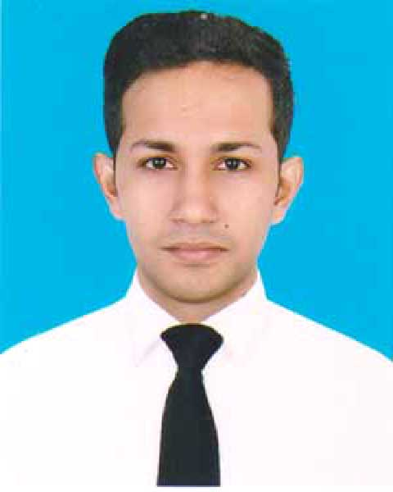
RESUME
OF
YEASIN ARAFAT SHAJAL
Mobile: 01677837578
CARRIER OBJECTIVE:
Looking for a challenging job for a suitable position in any esteem organization where I can use my ability at its best. To obtain a position and can show my immense aspiration to become a quick learner and prove myself as sincere and energetic person through extensive hard work and integrity.

EDUCATION BACKGROUND:

B.B.A (Hons) : (Bachelor of Business Administration):
Name of the Institution : Mohammadpur Kendriya University College
Subject : Accounting
Session : 2011 -2012
Result Obtained : G.P.A- 2.63 (out of 4)
Passing year : 2017
Name of Board : National University
H.S.C (Higher Secondary Certificate):

Name of Institute : Dhaka College
Group : Business Studies
Board : Dhaka
Result : GPA- 3.80 (out of 5)
Passing year : 2011

S.S.C (Secondary School Certificate):
Name of Institute : Mohammadpur Govt. High School
Group : Business Studies
Board : Dhaka
Result : GPA- 5.00 (out of 5)
Passing year : 2009

Computer Proficiency:
- Operating System : Windows XP, Windows 7.
- Application Program : MS Office, MS Excel, MS Power Point.
- Others : Internet, E-Mail etc.

Language Proficiency:

Language | Speaking | Reading | Writing
Bengali | Excellent | Excellent | Excellent
English | Good | Excellent | Excellent

Personal Information:
Name : Yeasin Arafat Shajal
Fathers Name : MD. Ismail Hossain
Mothers Name : Israt Jahan Hashi
Present Address : 12A/7A,Hazi Chinu Mia Road,Tikkapara
Mohammadpur Dhaka-1207
Permanent Address : Vill:Chilarchar, P.O:Kalikapur,
P.S : Madaripur, Dist: Madaripur
Date of birth : 10 -12- 1993
Religion : Islam
Marital Status : Unmarried
Nationality : Bangladeshi

Experience:

1. Work RA(Retailer Assistance) in Marlboro project under Sky Tracker ltd.(1.5 years)
2. Work BP(Brand Promoter) in Huwai Mobil Phone Company.(5 month)
3. Work Accounts Manager in Bims Digital Sign.(2years)
4. Work Merchant Relationship Manager in SSL wireless Company.

Declaration:

I hereby declare that all the information stated above is correct and I have all the necessary documents to support the information have provided.

Sincerely



Yeasin Arafat Shajal

Date: 27/02/2019

